Hello guys...!!!!!

This is a project depicting about hot to create your very own Cryptocurrency. As it is my currency I've given the name Prajcoin. In this project you can perform transactions between 3 different users. This project is a local server project. So the users will be different servers on your computer systems. This project is completely done in python. The requirements for this project are:

1. Anaconda Navigator or any python IDE

2. An internet connection

3. Postman App

This is a snippet of postman to check whether you’ve downloaded the right thing.

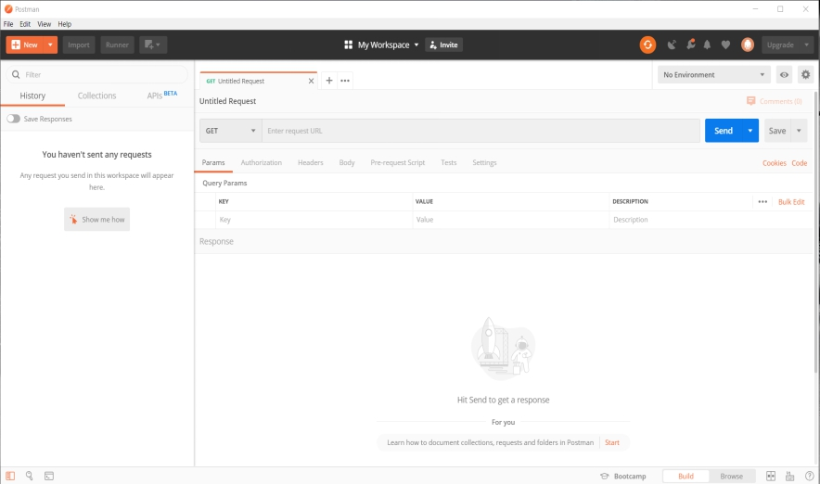

Steps for execution:

1. Copy the downloaded folder to any desired location.
2. Open anaconda navigator and inside that open Spyder IDE.
3. Open all the .py files from the downloaded folder.
4. Run the prajcoin_node_5001.py, prajcoin_node_5002.py, prajcoin_node_5003.py in three different terminals in Spyder.
5. Open Postman app.
6. Enter 3 requests(<http://127.0.0.1:5001>, <http://127.0.0.1:5002> & <http://127.0.0.1:5001>) in 3 consecutive “Enter request URL” tabs.
7. Now come to the first request ,in Body, click on raw and change the text to JSON 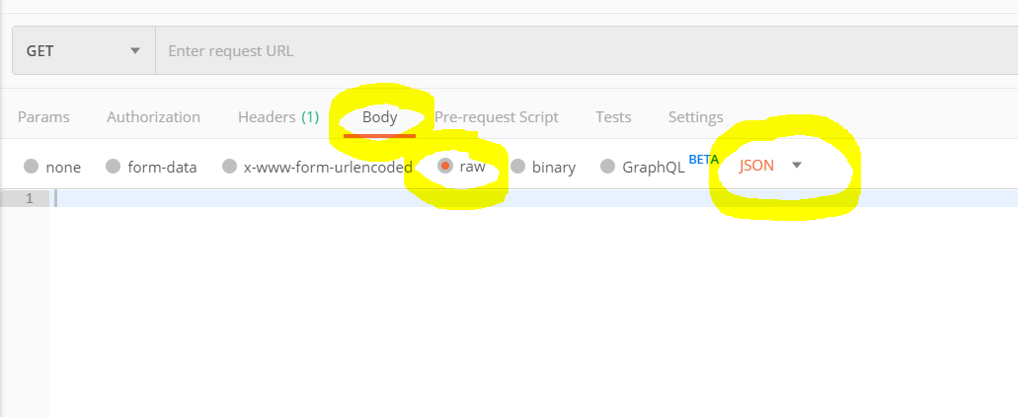
8. Now in raw, copy the contents of nodes.py file and paste here
9. Now enter the first request as <http://127.0.0.1:5001/get_chain> . Repeat this in all the requests.
10. Now come back to first request and enter <http://127.0.0.1:5001/mine_block> request and hit enter, then a new block will be created. Now again type the get chain request. New blockchain is created with newly mined block.
11. Now go to second request and type <http://127.0.0.1:5002/replace_chain> and Hit enter. Repeat this step for localhost 5003 also. As you can see all the hosts are now connected.

NOW TIME TO MAKE TRANSACTION

1. Open first request tab. In body,open raw and paste the contents from the transactions.py file. Also change the text to JSON.
2. Now change the request to Post , alter the contents of raw as per with whom you want to make transactions with.
3. Type the <http://127.0.0.1:5001/make_transaction> request.
4. Now type mine_block request and make sure you change the request to GET from POST. Hit Enter. And you will find the transaction is executed.
5. Now using the replace_chain request in other server’s tab you can create the chain for each host.

Tadaaa..!!!!

You have your own CryptoCurrency……!!!!!